**How to use the DaanMatch India NGO App:**

Go to the App [AT THIS LINK](https://daanmatch.maps.arcgis.com/apps/instant/nearby/index.html?appid=d406d9577ab74e199ca43c8de0cc2f4c)

Your Attention is directed to the upper left part of the screen, this is where the search tool is located.

Click where it says “***Find NGO or Place ’’*** and start typing either the name of an NGO or a city or village. Pictured below is an image of the search box :

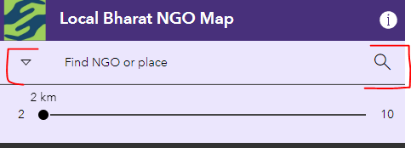



On a mobile app the user can push the ‘***My*** ***Location’*** button, and the map will zoom to that location and highlight the NGO’s within a 2 mile radius. Note the radius Circle can be extended for up to 10 miles as shown in the picture above. Also note that pushing the ‘***My*** ***Location’*** only works if you are in India.

You can also click on the map and it will zoom to that location and show all the NGO’s within the search radius circle as shown below:

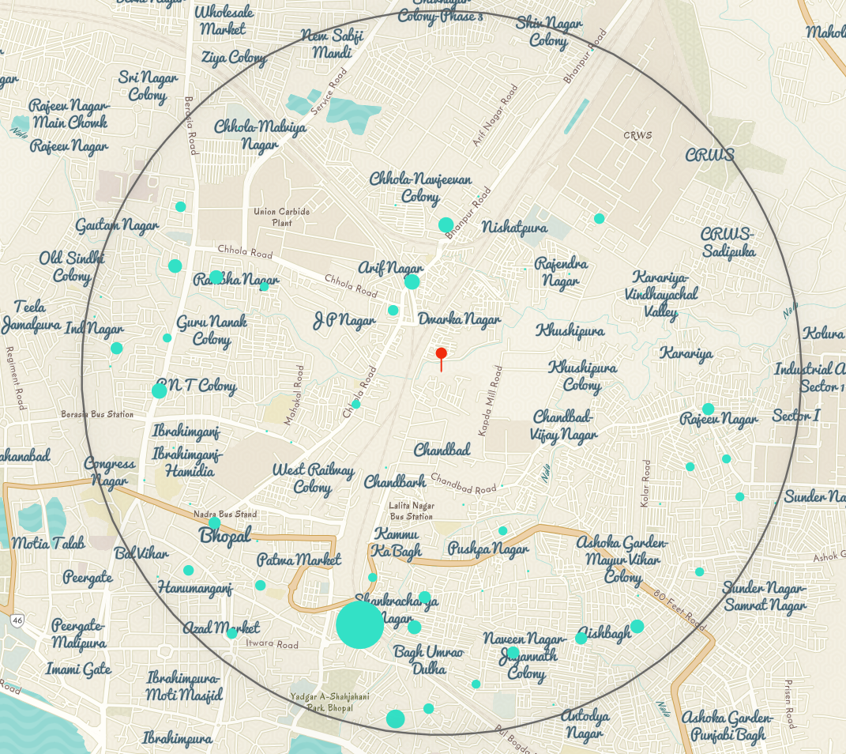

The search box  is set up to search by NGO Name, City, or Village. When you start typing you will see the App making suggestions based on NGO name or City\Village, as seen in the pictures below:

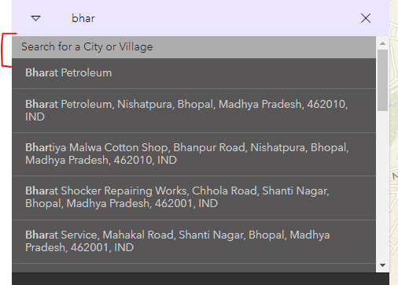

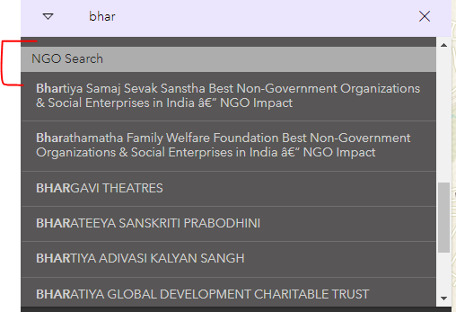

Once you find what you’re looking for in the Search box, select that location and the map will zoom to your selection as shown in the picture below:

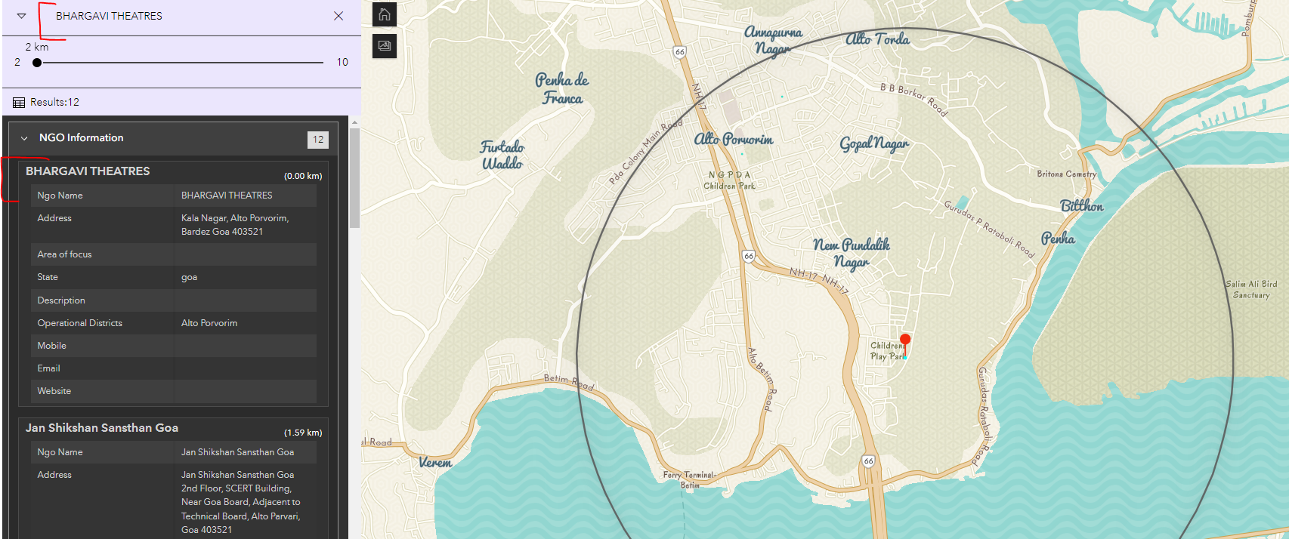

Searching and using the App is just as easy as that.